Functional & Performance Testing Template
Model Performance Test

Team ID | SWTID-2026-7899
Project Name | Auto Ticket Classification using Flow Designer
Maximum Marks

Test Scenarios & Results
Test Case ID | Scenario (What to test) | Test Steps (How to test) | Expected Result | Actual Result | Pass/Fail
FT-01 | Text Input Validation (Short Description) | Open a new School IT ticket and enter valid text (e.g., “Network issue”) in Short Description | Valid text is accepted and the ticket gets an auto-number | Short Description “Network issue” was accepted for ticket SCH0001006 (Fig 1). Invalid / blank input case not captured. | Pass (valid input)
FT-02 | Choice Field Validation (Category → Subcategory) | Select each Category and open the Subcategory list | Only the matching Subcategory is offered | Network → Wi-Fi, Hardware → Projector, Performance → Slow Computer (Figs 2–4). Access → Forgot Password is defined in the dependent-value list (Fig 5). | Pass
FT-03 | Auto-Classification (Category / Subcategory) | Create a ticket whose Short Description has a keyword (Wi-Fi/Network, Projector, Forgot password, Slow computer); save and reload | Category and Subcategory are filled automatically for the keyword | SCH0001006 (“Network issue”) shows Category = Network, Subcategory = Wi-Fi (Fig 1). That screenshot is the unsaved New-record form, so it does not yet prove the flow set them. Projector, Password and Slow rules not yet tested. | Partial
FT-04 | Flow & Email Notification Check | Submit a ticket, then open System Logs > Emails and search the subject | Confirmation email is generated for the caller by the flow | Email “Your Request for the issue has been submitted” is logged for the caller (Fig 6); its header shows source FlowDesigner (Fig 7). Status is send-ready (queued, SMTP). | Pass
PT-01 | Response Time Test | Check the flow run time from ticket creation to classification (Flow Executions) | Should be under 3 seconds | Not yet measured. | Pending
PT-02 | Concurrent Ticket Test | Create several tickets at the same time and check the flow keeps up | Flow should not slow down | Not yet tested. | Pending
PT-03 | File Upload Load Test (e.g., PDFs) | Upload multiple PDFs and check processing | Should work smoothly without crashing | Not applicable – this project has no file-upload feature. | N/A

Test Evidence (Screenshots)
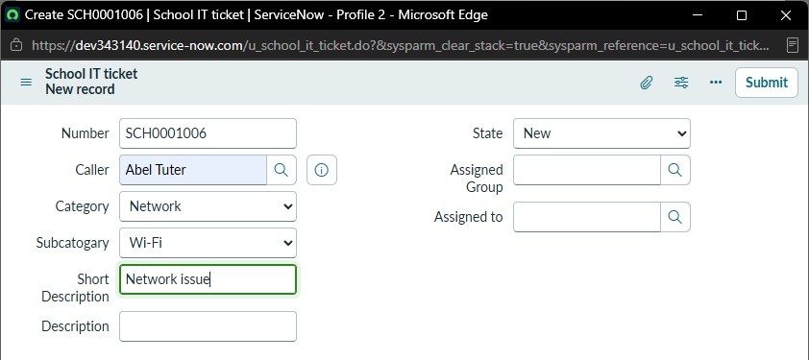
Fig 1 – Ticket SCH0001006 – Short Description “Network issue”; Category = Network, Subcategory = Wi-Fi
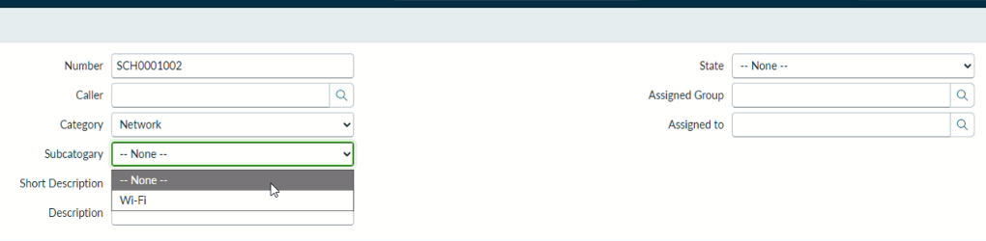
Fig 2 – Category = Network → only Wi-Fi offered
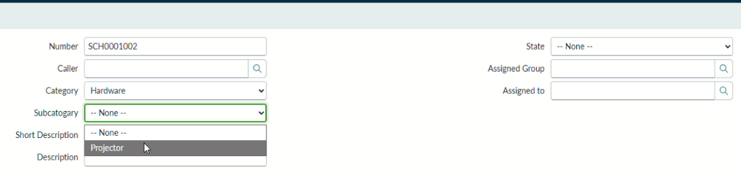
Fig 3 – Category = Hardware → only Projector offered
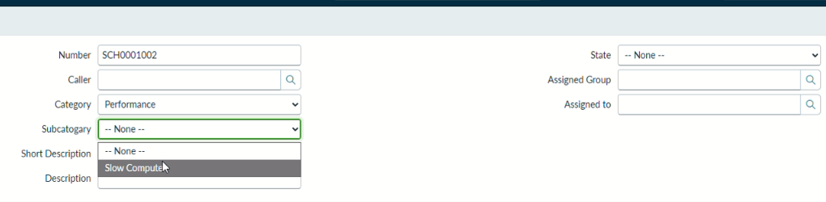
Fig 4 – Category = Performance → only Slow Computer offered
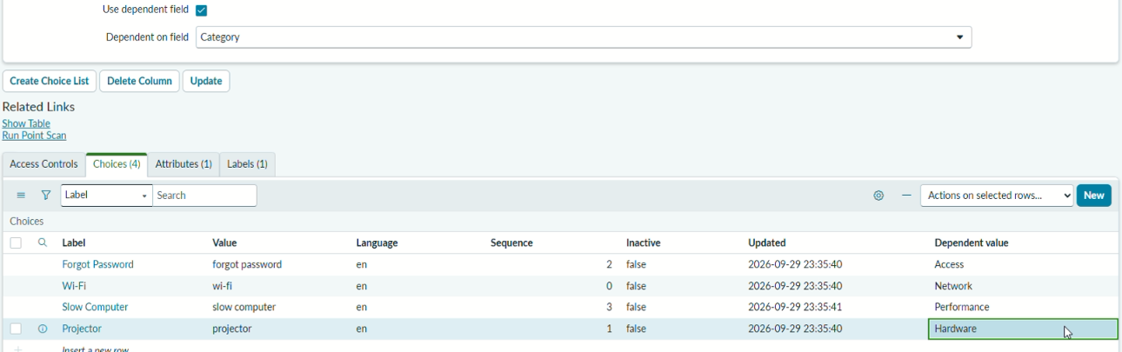
Fig 5 – Subcategory dependent values (Access, Network, Performance, Hardware)
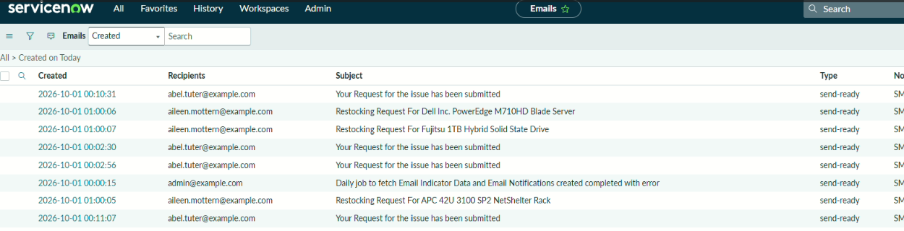
Fig 6 – Emails log – confirmation emails sent to the caller
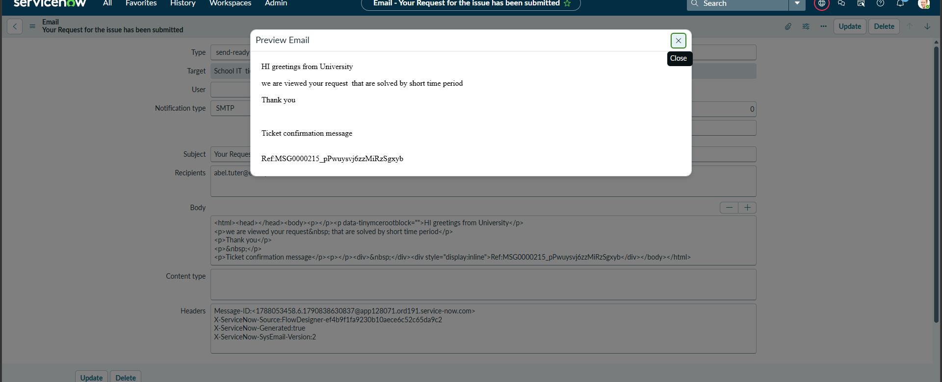
Fig 7 – Email preview – generated by Flow Designer (X-ServiceNow-Source: FlowDesigner)

